**DBMS ASSIGNMENT 1**

**CLASS: TE B**

**ROLL NO: 322008**

**Problem Statement:** Study of Open Source Relational Databases : MySQL

**Screenshots:**

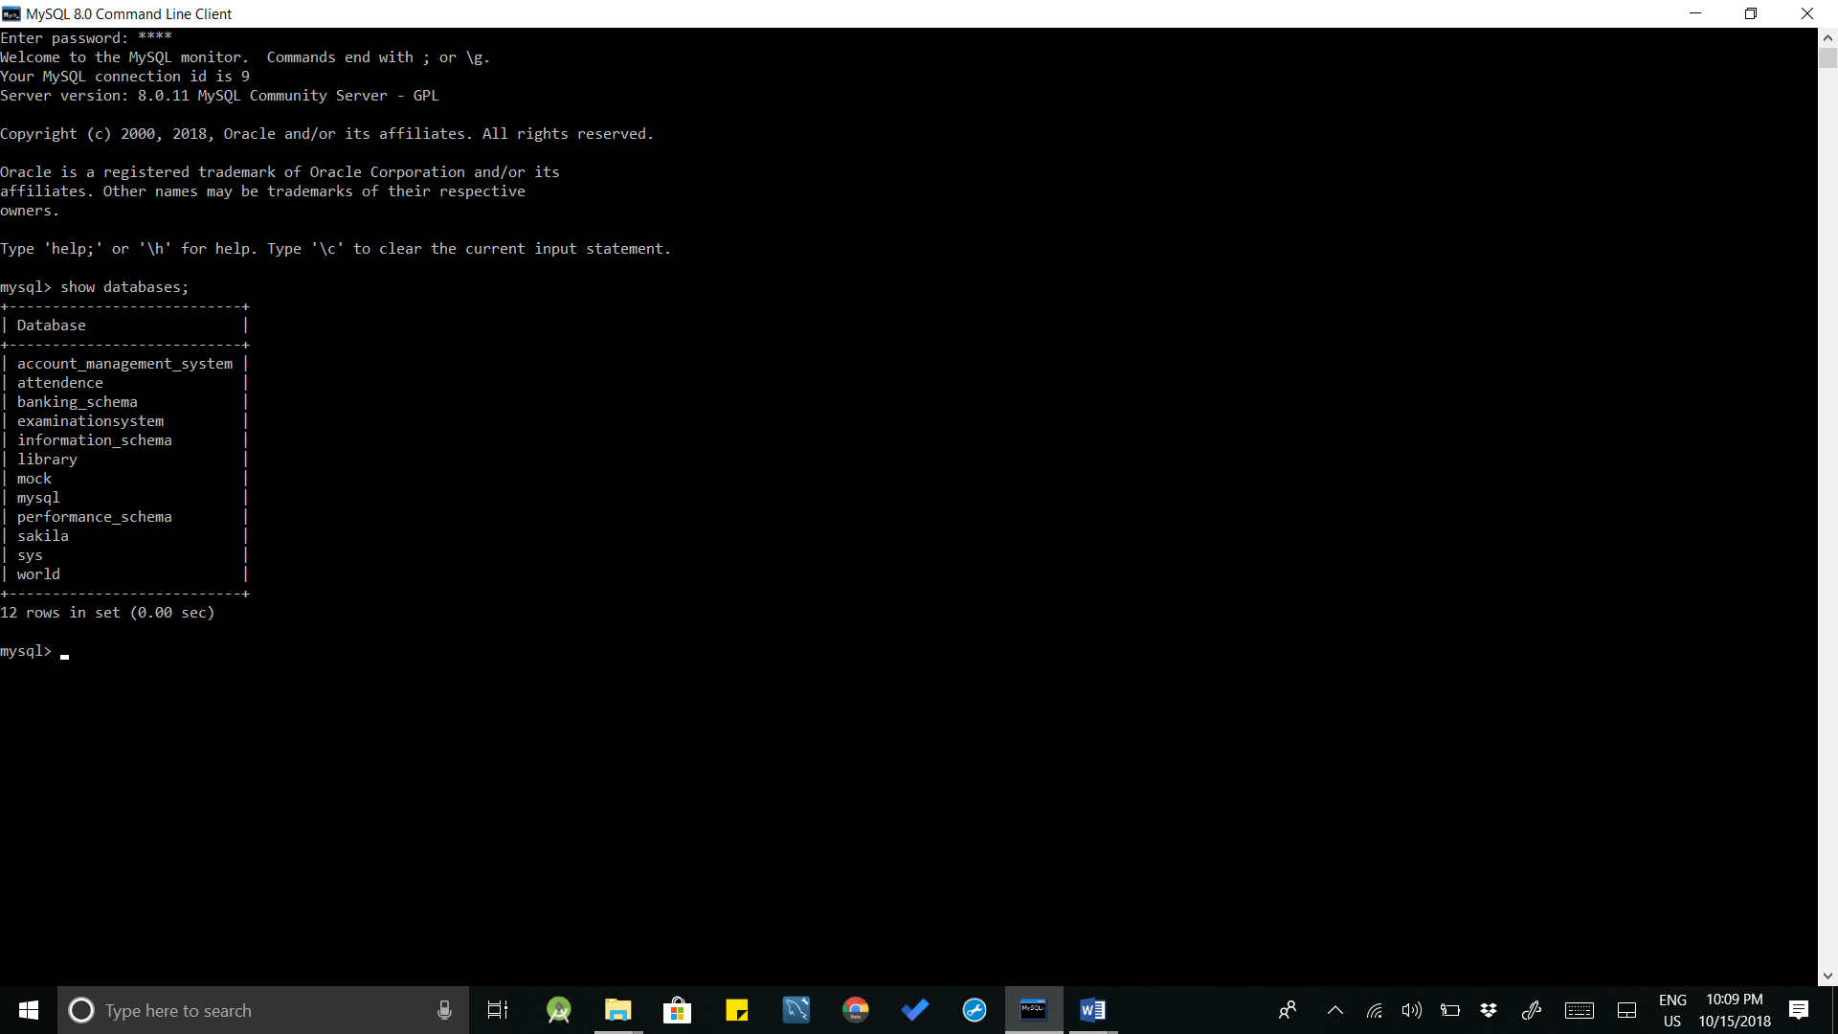

**Query:** show databases;

**Conclusion:** Mysql database was studied successfully.